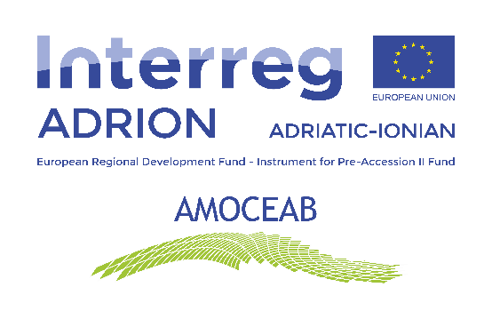

**Project type/Action:** INTERREG V-B Adriatic-Ionian ADRION Programme 2014-2020, Extraordinary fifth call for proposals – Priority 1 and 2 Application Form

**Project duration:** 9 months  
**Start of the project:** 2.1.2023  
**End of the project:** 30.9.2023

**Partnership: 10 partners, 7 Universities**

1. Polytechnic University of Marche
2. Alma Mater Studiorum – University of Bologna
3. Special Research Funds Account of Technical University of Crete
4. Agricultural University of Tirana
5. University of Sarejevo
6. School of Advanced Social Studies in Nova Gorica
7. University of Zagreb, Faculty of Food Technology and Biotechnology
8. Faculty of Technology and Metallurgy, University of Belgrade, Republic of Serbia
9. Chamber of Economy of the Federation of Bosnia and Herzegovina
10. CNA Emilia-Romagna

Web site of the project: <https://amoceab.adrioninterreg.eu>

**Project description:**

Starting from the need to foster the thematic link between Circular Economy and BioEconomy, both having for example, food waste, biomass and bio-based products areas of intervention, the project “Adrion Master On Circular Economy and BioEconomy (AMOCEAB)” aims to raise specific competences in these fields, through the establishment of a Transnational Network, an a Master’s Degree Programme in the ADRION Area. The project involve high research institutions and business support centres within the ADRION Area.

**Project main aim:**

AMOCEAB aims to increase specific skills through the establishment of a Transnational Network and the organization of a Master’s Degree Programme in the ADRION Area. This Master will enhance the skills of the students involved and will support business organizations to develop solutions and know-how focused on the green sustainability. Main topics:

* Environmental engeneering
* Biotechnology
* Biodiversity
* Circular Economy
* Social impact
* Sustainable business models
* Digitalization

**Results/Activities:**

1. Development of solutions and knowledge on Circular and Bio-Economy
2. Development of a joint academic path to create new expertise on Circular and Bio-Economy
3. Increase the capacity of universities & business support organisations to produce expertise in Circular and Bio-economy solutions
4. Creation of a transnational network of universities & organizations active in the Circular and Bioeconomy fields